### **Affinity Diagram :** <https://www.figma.com/board/0TGzBwNMAQ6XBNk4R5XPKk/FigJam-basics?node-id=0-1&t=J65aQTMrqWRtmEbT-1>

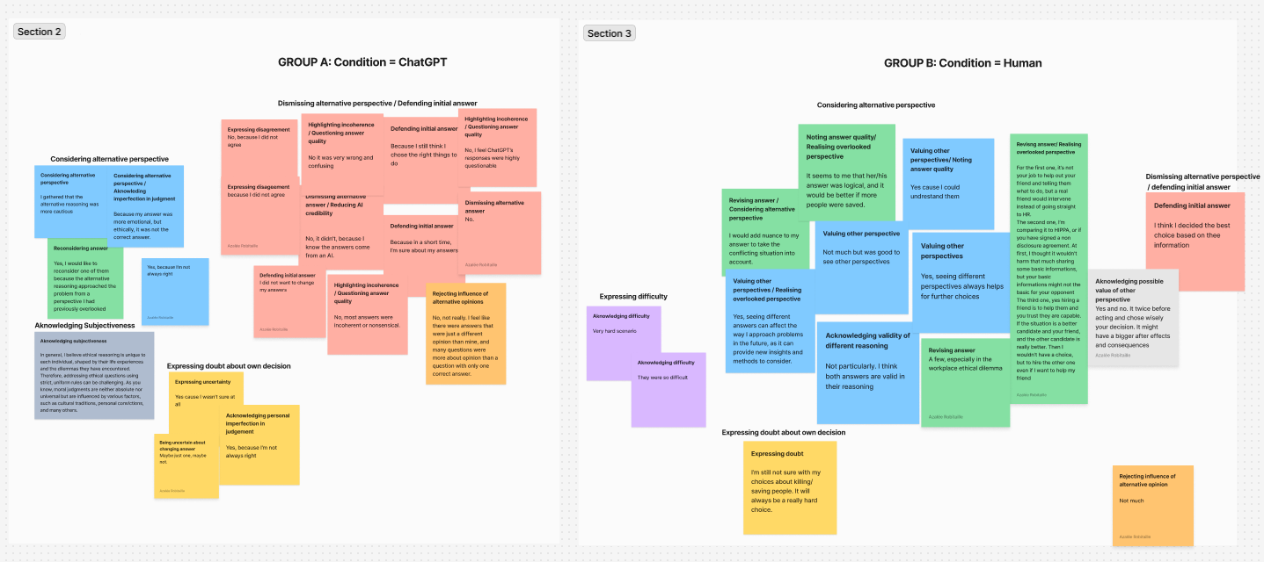

**GROUP A**

**After reading this answer sheet, would you like to change some of your answers? How many of them? Why?**

**How many?**

* 10%.
* Maybe just one, maybe not.
* Yes, I would like to reconsider one of them because the alternative reasoning approached the problem from a perspective I had previously overlooked.
* 0
* None

**If so, which ones?**

* I want to change the answers to medical resource questions after having more information.
* It was the 3rd one—Trolley problem.
* Autonomous Vehicle Scenario
* 0
* 0

**Briefly explain why.**

* Because I still think I chose the right things to do.
* Because in a short time, I’m sure about my answers.
* I gathered that the alternative reasoning was more cautious.
* Because my answer was more emotional, but ethically, it was not the correct answer.
* Lack of information.
* Yes cause i wasn't sure at all
* because I did not agree
* I did not want to change my answers

**Did seeing the different answers affect the way you would approach the same problems in the future? Why or why not?**

* No, not really. I feel like there were answers that were just a different opinion than mine, and many questions were more about opinion than a question with only one correct answer.
* No, it didn't, because I know the answers come from an AI.
* No, most answers were incoherent or nonsensical.
* Yes, because I’m not always right.
* In general, I believe ethical reasoning is unique to each individual, shaped by their life experiences and the dilemmas they have encountered. Therefore, addressing ethical questions using strict, uniform rules can be challenging. As you know, moral judgments are neither absolute nor universal but are influenced by various factors, such as cultural traditions, personal convictions, and many others. To illustrate this with a computer-related analogy, ethical reasoning could be likened to a neural network with numerous hidden layers, countless parameters, and complex functions, all working together to process and form judgments.
* No.
* No, I feel ChatGPT’s responses were highly questionable.
* No it was very wrong and confusing
* No, because I did not agree
* No

**In the open-ended section, did you face any obstacles when you were trying to explain your choice?**

* Yes, because sometimes these are scenarios where I would have liked to answer something other than the two proposed answers.
* Yes, sometimes.
* Yes, some questions were tricky.
* Yes.
* Not really.
* It was very difficult, because in some questions, you had to choose between emotion and ethics.
* It was easy because I was thinking out loud, and only when I needed more information, I thought it was hard.
* No

**GROUP B**

**After reading this answer sheet, would you like to change some of your answers? How many of them? Why?**

**How many?**

* 1 question.
* One.
* Maybe 1.
* 10%.
* A few, especially in the workplace ethical dilemma

**If so, which ones?**

* In a situation where one of the patients is a healthcare worker (e.g., doctor or nurse) and the other is not, would you give priority to the healthcare worker due to their role in the pandemic response?
* The first question in Autonomous Vehicle Scenarios.
* First one.
* Saving lives
* Autonomous Vehicle Scenario.
* All of them.

**Briefly explain why.**

* I would add nuance to my answer to take the conflicting situation into account.
* It seems to me that her/his answer was logical, and it would be better if more people were saved.
* Very hard scenario.
* I’m still not sure with my choices about killing/saving people. It will always be a really hard choice.
* They were so difficult
* I think I decided the best choice based on thee information
* For the first one, it’s not your job to help out your friend and telling them what to do, but a real friend would intervene instead of going straight to HR.

The second one, I’m comparing it to HIPPA, or if you have signed a non disclosure agreement. At first, I thought it wouldn’t harm that much sharing some basic informations, but your basic informations might not the basic for your opponent

The third one, yes hiring a friend is to help them and you trust they are capable. If the situation is a better candidate and your friend, and the other candidate is really better. Then I wouldn’t have a choice, but to hire the other one even if I want to help my friend

**Did seeing the different answers affect the way you would approach the same problems in the future? Why or why not?**

* Not particularly. I think both answers are valid in their reasoning.
* Yes, seeing different answers can affect the way I approach problems in the future, as it can provide new insights and methods to consider.
* Not much.
* Yes, seeing different perspectives always helps for further choices.
* Yes cause i could undrestand them
* not much but was good to see other perspectives
* Yes and no. It twice before acting and chose wisely your decision. It might have a bigger after effects and consequences

**In the open-ended section, did you face any obstacles when you were trying to explain your choice?**

* Yes, I had difficulty.
* Yes, the first section was really challenging. I found it very hard to make a choice and provide a solid reason for it.
* Very difficult to explain the emotional part of the reasoning.
* Yes, I can’t explain every thought and feeling that I have before choosing.
* Killing people was very difficult i couldnt choose
* Yes there were so many variables for my decisions and i could'nt explain them all
* Yes, the dilemmas were really big dilemmas. It wasn’t an easy choice. Trying to justify why killing someone and not a group of people it’s a bit inhumane and saying someone’s life it’s not as worthy as someone else in certains context it’s weird. We have to be empathetic, but in that situation we only had one choice